 | 7.2.15 Editors - 3D Viewport - Tool Shelf - Grease Pencil - Vertex Paint Mode
Table of content
Tool Shelf - Grease Pencil - Vertex Paint Mode 1
Draw 1
Blur 1
Average 1
Smear 1
Replace 1
Annotate tools 2
Select Tools 2

Tool Shelf - Grease Pencil - Vertex Paint Mode
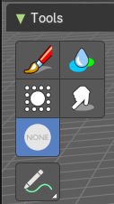
In this Mode you will mainly find brushes in the tool shelf.

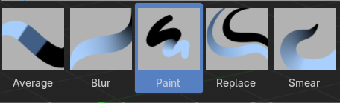
Draw
Paint vertices.

Blur
Blur the color.

Average
Blends the color under the brush.

Smear
Smear the colors.

Replace
Replaces the vertex color under the mouse with the current color.

Annotate tools
The annotate tools at the end of the list are explained in the chapter 7.1.1 Editors - 3D View - Tool Shelf - Object Mode. We won't cover this tools again here.

Select Tools
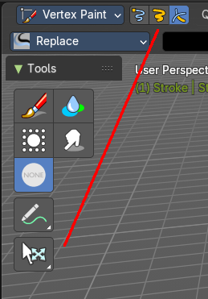
When you activate one of the mask modes then the select tool group appears. It is explained in the chapter 7.1.1 Editors - 3D View - Tool Shelf - Object Mode. We won't cover this tools again here.

